# Database and Data Warehouse Design

## Turner Sale

## MDS523 Final Project

# Section 1 – Requirements

## Business Description

This model is basely loosely on an ongoing business project at my current employer. The company produces conveyor equipment for organizations around the world and has a US based entity that focuses exclusively on conveyor manufacturing and engineering. The assembly process is designed to operate in work centers, producing each product type in its own area. This necessitates the usage of level loading tools and capacity planning that was previously not done. In addition, the data warehouse will be set up to then provide data to external sources so as to provide a security buffer between the productive system and outside companies/users. Much of the daily operations look like other manufacturing floors, save for the fact that most customer purchase a mix of product lines for different purposes.

Maintaining user interactivity is of utmost importance as management has increasingly come to rely on new analytic platforms and are beginning to make more data driven decisions. This has led to a new need to provide tooling (as IT controls all data access and design) to go along with process improvements. The conveyor industry is highly competitive with many larger firms, and as such business must evolve quickly and efficiently, including new table and data warehouse tooling.

## Business Problem

The most pressing problem is that of level loading the newly created work centers. Previously labor could be move around to separate work benches to produce and type of product, but this was vastly more inefficient for stockroom operations and shipment. The new work centers therefor must have known available capacities, the flexibility to change them on the fly, to schedule work to each work center, and to understand sales projections into the future for work center level loading and business commitments. Although there are hundreds of tables in the operation ERP, this will only view the tables needed for this specific work function.

## Business Requirements

### Operational System

* Only accessible through the Microsoft Dynamics Navision client
* Real-time production scheduling and loading
* Real-time production claiming
* Ability to change work center parameters such as capacity
* Ability to add and modify work centers
* Ability to reroute productions to new area
* Ability to create new productions and new items
* Ability to predict production volume based solely on sale value

### Data Warehouse

* As close to real-time data as possible
* Only method by which visualizations and external access can access data
* Exclusively used for analytics, non-productive
* Additional calculations for averages and estimates

## Technical Requirements

* Microsoft SQL Server (2 separate servers)
* Microsoft Dynamics Navision
* SQL Server Management Studio
* Microsoft Power BI

## Data Requirements

### Operational System

* All production orders must be retained in history and unique
* Item number may drive routings, but routings must be modifiable
* Work centers must be schedulable but are not used to determine production dates
* Ability to modify production dates by a level loading operator
* Ability to change the work center capacities on a granular level

### Data Warehouse

* Cannot be accessed directly by users
* No data entry, all data changes are driven by operational
* Aggregation must be done to standard time scales

## Business Rules

* Each work center can only be part of one group
* Each work center group may contain many work centers
* Sales orders drive the creation of production orders and only one can be made per line
* Production orders drive the routing lines (pulled from item information) and may have many for a single production
* Routing lines for a production order may only have one Assembly routing
* Dates must be based on fiscal year and quarter, with calendar months, weeks, and dates coming after
* Booked sales lines that do not contain production order information must be converted to specialty production orders for capacity planning (knowing that it will change)

# Section 2 – Data Models

## Conceptual Data Model

### Attribute and Model Descriptions

* Sales Order Line
  + Contains the customer, shipping address, shipment dates, quantities and pricing data
  + Contains many foreign keys to other normalized tables for things like standard costs and item categories
  + Certain lines are converted to production orders while some items are directly sold to customer after picking operations
* Item
  + All items, including produced and purchased items
  + Unique item number as the primary key
  + Contains a routing reference number which is used for the default routing line creation later
* Production Order Line
  + Contains information on the production type, date, quantities and painting
  + Uses the assembly routing to derive a field for ease of access
  + Production order number is a unique identifier always beginning with the letter “M”
* Production Order Routing Line
  + Many lines for each production, including picking operations, paint operations, inbound warehouse times, and assembly
  + Must only contain one assembly step for each production order
  + Defaults are taken from the item number that was used to generate the production order
  + Contains work center numbers for every process step
* Work Center
  + Each work center that is in the company
  + Ability to block and obsolete work centers on the high level
  + Contains the default worker number, efficiencies, as well as the physical location of the work center
  + Must only be part of a single group (such as assembly, fabrication, shipping, etc.)
* Work Center Group
  + The one half of a one to many relationship with Work Center
  + Contains cost center information for budgeting
  + Used for aggregation level and blocking of large areas of production
* Calendar Entries
  + Single entry for every work center and work period (breaks and closing times determine the start and end periods from the company calendar)
  + Ability to change each entry for new efficiencies, absence, etc.
  + Modifiable in productive system to dynamically change the capacities

## Logical Data Model

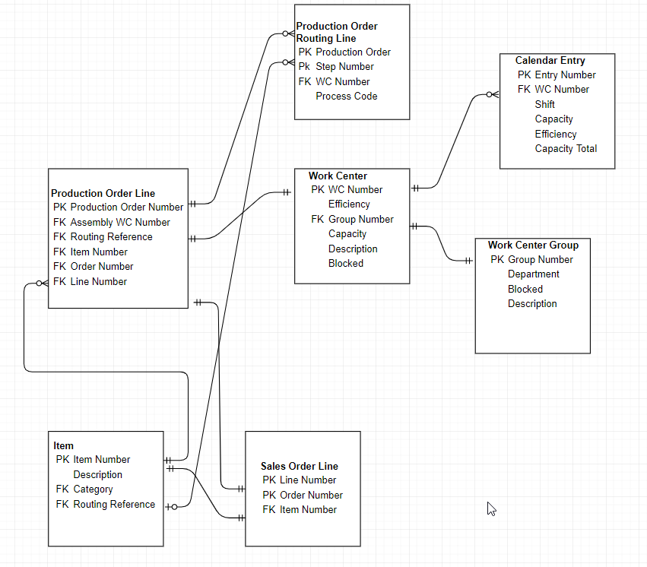

### Attribute and Model Descriptions

* Production Order Line
  + Production Order Number – PK – unique number starting with M then 7 digits
  + Assembly WC Number – FK – the work center where the item will be assembled
  + Routing Reference Number – FK – unique number typically the same as the item number
  + Item Number – FK – used to determine the actual item produced and the type of production
  + Order Number – FK – the sales order number that generated the demand for production
  + Line Number – FK – the sales order line that specifically generated the demand
* Production Order Routing Line
  + Production Order Number – FK and PK – may have several lines for each production order
  + Step Number – PK – the subline of the production order number
  + WC Number – FK – work center relation
  + Process code – information such as PICK, PAINT, or ASSEMBLE
  + Run Time – amount of time the step will take
* Item
  + Item Number – PK – distinct item variants
  + Description – item information
  + Category – FK – an item category code, relation not defined here
  + Routing Reference – FK – the default routings for the item, relation not defined here
* Sales Order Line
  + Order Number – PK – purchase order
  + Line Number – PK – subline of the order number
  + Item Number – FK – the item that is being sold to customer
* Work Center
  + WC Number – PK – identifier of the work center
  + Group Number – FK – relation to the work center group table
  + Description – work center name and info
  + Efficiency – expected production rate
  + Capacity – number of workers
  + Blocked – whether the work center can be used or not
* Work Center Group
  + Group Number – PK – information like ASSY, FAB, etc.
  + Department – FK – department that bears the cost, relation not defined here
  + Description – detailed info
  + Blocked – whether to block all associated work centers in this group – pushed to work center table through validation in application
* Calendar Entry
  + Entry Number – PK – unique entry number generated when the calendar plan is recalculated for a date range
  + Date – no defined relation in productive, will have relation in data warehouse
  + WC Number – FK – associated work center
  + Shift – shift number
  + Capacity – entered when the line is generated, default is from the work center
  + Efficiency - entered when the line is generated, default is from the work center
  + Capacity total – Capacity * Efficiency/100

# Section 3 – Physical Database Design

## Normalized Forms

All tables are normalized by default due to design of the original database. Normalization therefor was not needed in this instance. Steps undertaken by original designers to ensure that each transaction and fact table was normalized has thusly enabled users such as myself to focus on the analytics and design rather than the ERD.

## Sample Tables

* Production Order Line

|  |  |  |  |  |  |  |
| --- | --- | --- | --- | --- | --- | --- |
| Production Order Number | Ending Date (Due Date) | Assembly WC Number | Routing Reference Number | Item Number | Order Number | Line Number |
| M0000001 | 05/31/2019 | ASY-ITR-130 | E001 | E001 | 1111111 | 1 |
| M0000002 | 05/31/2019 | ASY-SPECIALS | E002 | E002 | 1111112 | 1 |
| M0000003 | 05/31/2019 | ASY-ITR-130 | E001 | E001 | 1111113 | 1 |
| M0000004 | 05/31/2019 | ASY-NBC-165 | E003 | E003 | 1111112 | 2 |
| M0000005 | 05/30/2019 | ASY-CZB-150 | E010 | E004 | 1111114 | 1 |

* Production Order Routing Line

|  |  |  |  |  |
| --- | --- | --- | --- | --- |
| Production Order Number | Step Number | WC Number | Process Code | Run Time |
| M0000001 | 1 | PICK | PICK | 1 |
| M0000001 | 2 | ASY-ITR-130 | ASSY | 1 |
| M0000002 | 1 | PICK | PICK | 1 |
| M0000002 | 2 | ASY-SPECIALS | ASSY | 5 |
| M0000005 | 1 | PICK | PICK | 1 |

* Item

|  |  |  |  |
| --- | --- | --- | --- |
| Item Number | Description | Category | Routing Reference Number |
| E001 | ITR bed | PRODUCT | E001 |
| E002 | Customer bed | PRODUCT | E002 |
| E003 | NBC bed | PRODUCT | E003 |
| E004 | Roller | PURCHASE ITEM | E010 |
| E005 | O-ring | PURCHASE ITEM | E005 |

* Sales Order Line

|  |  |  |
| --- | --- | --- |
| Order Number | Line Number | Item Number |
| 1111111 | 1 | E001 |
| 1111112 | 1 | E002 |
| 1111112 | 2 | E003 |
| 1111113 | 1 | E001 |
| 1111114 | 1 | E004 |

* Work Center

|  |  |  |  |  |  |
| --- | --- | --- | --- | --- | --- |
| WC Number | Group Number | Description | Efficiency | Capacity | Blocked |
| ASY-ITR-130 | ASSY | ITR line | 100 | 10 | 0 |
| ASY-SPECIALS | ASSY | Specials area | 90 | 5 | 0 |
| PICK | STOCK | Picking | 90 | 10 | 0 |
| ASY-NBC-165 | ASSY | NBC line | 100 | 5 | 0 |
| ASY-CZB-150 | ASSY | CZB line | 100 | 5 | 0 |
| WELD | FAB | Welding station | 70 | 2 | 0 |
| BENCH1 | ASSY | Bench number 1 | 80 | 1 | 1 |

* Work Center Group

|  |  |  |  |
| --- | --- | --- | --- |
| Group Number | Department | Description | Blocked |
| ASSY | D001 | Assembly group | 0 |
| STOCK | D002 | Logistics group | 0 |
| FAB | D001 | Assembly group | 0 |
| MAINT | D003 | Maintenance group | 1 |

* Calendar Entry

|  |  |  |  |  |  |  |
| --- | --- | --- | --- | --- | --- | --- |
| Entry Number | Date | WC Number | Shift | Capacity | Efficiency | Capacity Total |
| 00001 | 05/31/2019 | ASY-ITR-130 | 1 | 10 | 100 | 10 |
| 00002 | 05/31/2019 | ASY-ITR-130 | 1 | 10 | 100 | 10 |
| 00003 | 05/31/2019 | ASY-ITR-130 | 2 | 10 | 100 | 10 |
| 00004 | 05/31/2019 | ASY-SPECIALS | 1 | 90 | 10 | 9 |
| 00005 | 05/31/2019 | ASY-NBC-165 | 1 | 100 | 5 | 5 |

## Table Creation Code

CREATE TABLE [Production Order Line] (

[Production Order Number] VARCHAR(255) NOT NULL,

[Ending Date] DATETIME NOT NULL,

[Assembly WC Number] VARCHAR(255) NOT NULL,

[Routing Reference Number] VARCHAR(255) NOT NULL,

[Item Number] VARCHAR(255) NOT NULL,

[Order Number] VARCHAR(255) NOT NULL,

[Line Number] INT NOT NULL,

);

CREATE TABLE [Production Order Routing Line] (

[Production Order Number] VARCHAR(255) NOT NULL,

[Step Number] INT NOT NULL,

[WC Number] VARCHAR(255) NOT NULL,

[Process Code] VARCHAR(255) NOT NULL,

[Run Time] INT NOT NULL,

);

CREATE TABLE [Item] (

[Item Number] VARCHAR(255) NOT NULL,

[Description] VARCHAR(255) NOT NULL,

[Category] VARCHAR(255) NOT NULL,

[Routing Reference Number] VARCHAR(255) NOT NULL,

);

CREATE TABLE [Sales Order Line] (

[Order Number] VARCHAR(255) NOT NULL,

[Line Number] VARCHAR(255) NOT NULL,

[Item Number] VARCHAR(255) NOT NULL,

);

CREATE TABLE [Work Center] (

[WC Number] VARCHAR(255) NOT NULL,

[Group Number] VARCHAR(255) NOT NULL,

[Description] VARCHAR(255) NOT NULL,

[Efficiency] INT NOT NULL,

[Capacity] INT NOT NULL,

[Blocked] BIT NOT NULL,

);

CREATE TABLE [Work Center Group] (

[Group Number] VARCHAR(255) NOT NULL,

[Department] VARCHAR(255) NOT NULL,

[Description] VARCHAR(255) NOT NULL,

[Blocked] BIT NOT NULL,

);

CREATE TABLE [Calendar Entry] (

[Entry Number] INT NOT NULL,

[Date] DATETIME NOT NULL,

[WC Number] VARCHAR(255) NOT NULL,

[Shift Code] INT NOT NULL,

[Capacity] INT NOT NULL,

[Efficiency] INT NOT NULL,

[Capacity Total] INT NOT NULL,

);

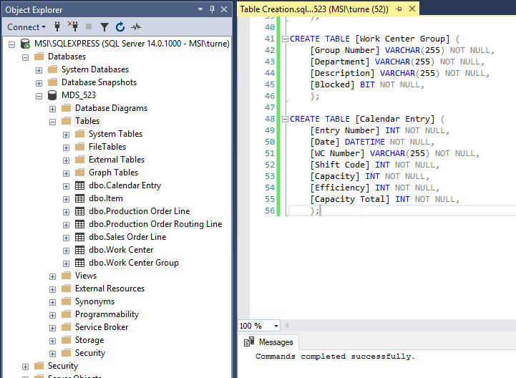

## Table Insertion Code

INSERT INTO [Production Order Line]

VALUES

('M0000001','05/31/2019','ASY-ITR-130','E001','E001','1111111','1'),

('M0000002','05/31/2019','ASY-SPECIALS','E002','E002','1111112','1'),

('M0000003','05/31/2019','ASY-ITR-130','E001','E001','1111113','1'),

('M0000004','05/31/2019','ASY-NBC-165','E003','E003','1111112','2'),

('M0000005','05/30/2019','ASY-CZB-150','E010','E004','1111114','1')

;

INSERT INTO [Production Order Routing Line]

VALUES

('M0000001','1','PICK','PICK','1'),

('M0000001','2','ASY-ITR-130','ASSY','1'),

('M0000002','1','PICK','PICK','1'),

('M0000002','2','ASY-SPECIALS','ASSY','5'),

('M0000005','1','PICK','PICK','1')

;

INSERT INTO [Item]

VALUES

('E001','ITR bed','PRODUCT','E001'),

('E002','Customer bed','PRODUCT','E002'),

('E003','NBC bed','PRODUCT','E003'),

('E004','Roller','PURCHASE ITEM','E010'),

('E005','O-ring','PURCHASE ITEM','E005')

;

INSERT INTO [Sales Order Line]

VALUES

('1111111','1','E001'),

('1111112','1','E002'),

('1111112','2','E003'),

('1111113','1','E001'),

('1111114','1','E004')

;

INSERT INTO [Work Center]

VALUES

('ASY-ITR-130','ASSY','ITR line','100','10','0'),

('ASY-SPECIALS','ASSY','Specials area','90','5','0'),

('PICK','STOCK','Picking','90','10','0'),

('ASY-NBC-165','ASSY','NBC line','100','5','0'),

('ASY-CZB-150','ASSY','CZB line','100','5','0'),

('WELD','FAB','Welding station','70','2','0'),

('BENCH1','ASSY','Bench number 1','80','1','1')

;

INSERT INTO [Calendar Entry]

VALUES

('0000','05/31/2019','ASY-ITR-130','1','10','100','10'),

('00002','05/31/2019','ASY-ITR-130','1','10','100','10'),

('00003','05/31/2019','ASY-ITR-130','2','10','100','10'),

('00004','05/31/2019','ASY-SPECIALS','1','90','10','9'),

('00005','05/31/2019','ASY-NBC-165','1','100','5','5')

;

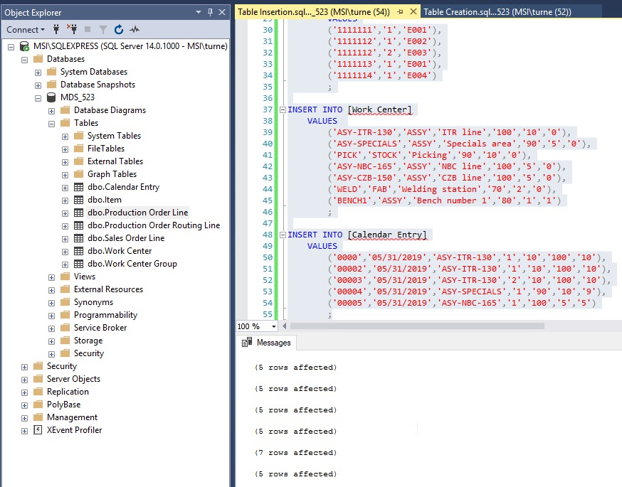

# Section 4 – Queries

Although this database structure is highly simplified and only has roughly 1 row per 1 million in the productive servers, it demonstrates the concepts at play and can be used to generate some insights into the data. The queries shown below only return a small number of entries, while the productive system may return many thousands or millions. An example of the report generated form the real data can be seen below as an example of the more complex and large scale dataset.

## Simple Queries

* All production order lines:
  + 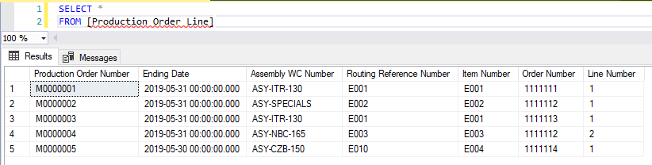
* All blocked work centers:
  + 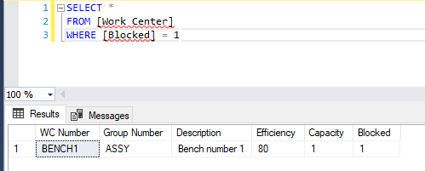
* Capacity by work center and date:
  + 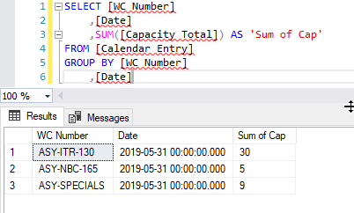
* Work centers order by efficiency:
  + 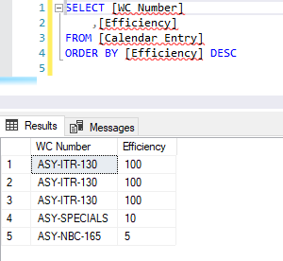
* Routing lines that are not assembly:
  + 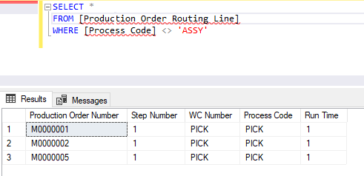

## Complex Queries

* Capacity available minus the need by work center:
  + 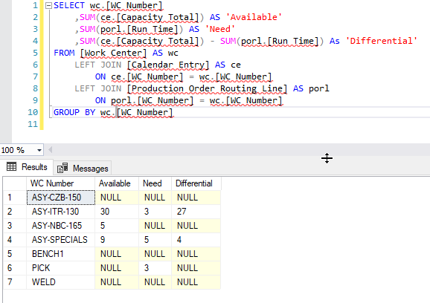
* Routing lines with blocked work centers (need to be addressed):
  + Thankfully there are none in this example
  + 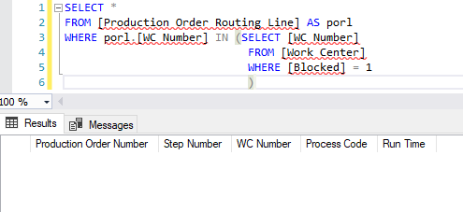
* Total number of routing steps and total run time by production order:
  + 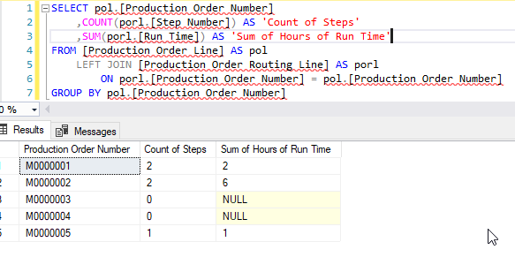
* Number of productions and run time by cell:
  + 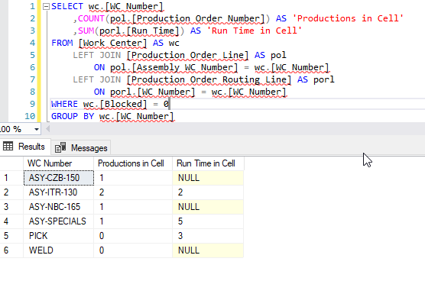
* Production orders and run time by item number:
  + 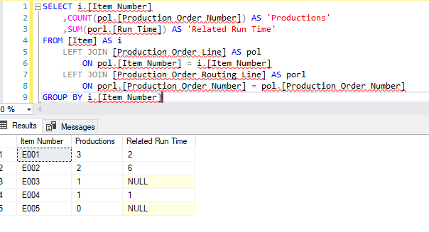

# Section 5 – Data Warehouse Design and Coding

## Data Warehouse Design

In this existing business, the data warehouse is being created using batch updates at set intervals (once an hour) where the data from the productive database above is being loaded into the data warehouse using merge statements for each table that is desired. The existing infrastructure is reliable enough for this to work for the majority of users, however, as we begin to expand it is becoming increasingly more useful to include more tables than previously defined in the refresh and more real-time calculations.

As business user counts grow, we have begun discussion of moving to a transactional replication model. This way we can capture all changes nearly in real-time, modify both the productive database and the data warehouse, and have two full copies of data. In addition to the operational database, we have CRM and HRM services that run outside of out ERP, as well as a newly designed warehouse management system that runs separately from the operational database and uses shared views to communicate with each other.

The steps being taken to move to this method are not needed here as they are many and as such it is fair to say that the refresh is being handled far better than previously done. The modeling of the data warehouse (in all incarnations) has perfectly matched the productive in its base form. This includes all the related fields, all schema changes, and all informational changes.

In addition to this pure copy, we are batching certain views and tables for quicker access. One such example is a modified production order view that includes all the hours that have been claimed by workers (such as assembly time, welding time, etc.) and the count of production order components that are still short (unable to be used for assembly, either not in house or not built as a subassembly yet).

The data is too complex to accurately recreate in this context, so several more complex queries will be attached below to demonstrate the utility I have built into the constantly evolving data warehouse.

## Data Marts

All data in databases is currently controlled by those in IT across the international units. Due to certain security and compliance concerns, all data is accessed either through the ERP, CRM, or HRM systems with their own validation and certain reporting capabilities, or through data warehouse/backup image queries performed primarily by me. This does make the lead time for ad hoc data and reporting to be a bit longer, but it ensures that all data is kept secure and standardized as previously we were reliant upon ODBC connection into Excel, a less than ideal solution.

Given the history of our data access and the lack of technical knowledge (such as SQL, Excel, or Power BI skills) data marts have been ruled out for the time being in our primary business. We do create some backup images of the systems for testing and development with only a subset of data, but this is very rarely done. In the future we are planning to release certain tables and relational models as Power Query driven workbooks accessible in Power BI Service. These workbooks will contain pre-canned data models and measures developed by those of us in IT with the abilities and then given to user groups. This allows us to provide accurate and standardized data models to users without security concerns and with strict control over access and versioning.

## Data Warehouse Queries

There are many uses for our existing data warehouse and I am proud to see that our organization has taken to the reporting quite well. These reports and KPI’s were few and far between at most levels of the organization and are now becoming increasingly common and more are on their way. Below is an example of one such report and the query that is being used to create a large portion of the data, as well as a few examples of the more interesting queries that I have developed for different user groups.

### Level Loading Example

SELECT pol.[Prod_ Order No_]

,CASE pol.[Status]

WHEN 0 THEN 'Simulated'

WHEN 1 THEN 'Planned'

WHEN 2 THEN 'Firm Planned'

WHEN 3 THEN 'Released'

WHEN 4 THEN 'Finished'

END AS 'Status'

,pol.[Line No_]

,pol.[Item No_]

,pol.[Sales Order No_]

,pol.[Segment]

,pol.[Sales Order No_] + ' - ' + pol.[Segment] AS 'Sales Order Key'

,pol.[Variant Code]

,pol.[Description]

,pol.[Shortcut Dimension 2 Code]

,pol.[Remaining Quantity]

,pol.[Finished Quantity]

,pol.[Ending Date Modifier]

,pol.[Modified Ending Date]

,pol.[Accuracy]

,pol.[Pick Operation Header No_] AS 'PH-A'

,(SELECT CASE poh.[Status]

WHEN 0 THEN 'Open'

WHEN 1 THEN 'Rel'

WHEN 2 THEN 'IP'

WHEN 3 THEN 'PC'

WHEN 4 THEN 'Comp'

END AS 'Status'

FROM [TGW-ERMANCO$Pick Operation Header] AS poh

WHERE poh.[Pick Operation Header No_] = pol.[Pick Operation Header No_]

) AS 'PH-A Status'

,pol.[Pick Operation Hdr_ No_ B-Side] AS 'PH-B'

,(SELECT CASE poh.[Status]

WHEN 0 THEN 'Open'

WHEN 1 THEN 'Rel'

WHEN 2 THEN 'IP'

WHEN 3 THEN 'PC'

WHEN 4 THEN 'Comp'

END AS 'Status'

FROM [TGW-ERMANCO$Pick Operation Header] AS poh

WHERE poh.[Pick Operation Header No_] = pol.[Pick Operation Hdr_ No_ B-Side]

) AS 'PH-B Status'

,porl.[Work Center No_]

,porl.[Run Time] AS 'Run Time/ Standard Hours Per Production'

,porl.[Run Time] * pol.[Quantity] AS 'Total Planned Run Time/ Standard Hours'

,porl.[Run Time] * pol.[Finished Quantity] AS 'Total Produced Run Time/ Standard Hours'

,cle2.[Sum of Reported Hours]

,pol.[Remaining Quantity] * porl.[Run Time] AS 'Remaining Run Time'

FROM [TGW-ERMANCO$Prod_ Order Line] AS pol

LEFT JOIN [TGW-ERMANCO$Prod_ Order Routing Line] AS porl

ON pol.[Prod_ Order No_] = porl.[Prod_ Order No_]

LEFT JOIN (SELECT cle.[Document No_]

,cle.[Work Center No_]

,SUM(cle.[Run Time]) AS 'Sum of Reported Hours'

FROM [TGW-ERMANCO$Capacity Ledger Entry] AS cle

GROUP BY cle.[Document No_]

,cle.[Work Center No_]

) AS cle2

ON cle2.[Document No_] = pol.[Prod_ Order No_]

AND cle2.[Work Center No_] = porl.[Work Center No_]

WHERE porl.[Process Structure Code] = 'ASS'

AND pol.[Due Date] BETWEEN DATEADD(month, -1, GETDATE()) AND DATEADD(year, 1, GETDATE())

AND pol.[Item Category Code] = 'PRODUCT'

UNION ALL

SELECT CONVERT(VARCHAR(30), 'M-' + sl.[Document No_] + '-' + sl.[Segment] + '-' + CONVERT(VARCHAR(30),sl.[Line No_])) AS 'Prod_ Order No_'

,CONVERT(VARCHAR(12), 'Quote') AS 'Status'

,CONVERT(INT, sl.[Line No_]) AS 'Line No_'

,CONVERT(VARCHAR(20), sl.[No_]) AS 'Item No_'

,CONVERT(VARCHAR(20), sl.[Document No_]) AS 'Sales Order No_'

,CONVERT(VARCHAR(30), sl.[Segment]) AS 'Segment'

,CONVERT(VARCHAR(53), sl.[Document No_] + ' - ' + sl.[Segment]) AS 'Sales Order Key'

,CONVERT(VARCHAR(10), sl.[Variant Code]) AS 'Variant Code'

,CONVERT(VARCHAR(50), sl.[Description] + ' for unit price of ' + CONVERT(VARCHAR, CONVERT(DECIMAL(10,2),sl.[Unit Price]))) AS 'Description'

,CONVERT(VARCHAR(20), sl.[Shortcut Dimension 2 Code]) AS 'Shortcut Dimension 2 Code'

,CONVERT(DECIMAL(38,20), sl.[Outstanding Quantity]) AS 'Remaining Quantity'

,CONVERT(DECIMAL(38,20), 0) AS 'Finished Quantity'

,CONVERT(INT, 0) AS 'Ending Date Modifier'

,CONVERT(DATETIME, sl.[Shipment Date]) AS 'Modified Ending Date'

,CONVERT(INT, sl.[Accuracy]) AS 'Accuracy'

,CONVERT(VARCHAR(20), 'PHBOOKORDER') AS 'PH-A'

,CONVERT(VARCHAR(4), 'Open') AS 'PH-A Status'

,CONVERT(VARCHAR(20), 'PHBOOKORDER') AS 'PH-B'

,CONVERT(VARCHAR(4), 'Open') AS 'PH-B Status'

,CONVERT(VARCHAR(20), sl.[Description 2]) AS 'Work Center No_'

,CONVERT(DECIMAL(38,20), 0) AS 'Run Time/ Standard Hours Per Production'

,CONVERT(DECIMAL(38,6), sl.[Unit Price] /

wcm.[Mean Unit Price per Run Time]

) AS 'Total Planned Run Time/ Standard Hours' --Expected run time based on average by work center

,CONVERT(DECIMAL(38,6), 0) AS 'Total Produced Run Time/ Standard Hours'

,CONVERT(DECIMAL(38,20), 0) AS 'Sum of Reported Hours'

,CONVERT(DECIMAL(38,6), sl.[Unit Price] /

wcm.[Mean Unit Price per Run Time]

) AS 'Remaining Run Time'

FROM [TGW-ERMANCO$Sales Line] AS sl

LEFT JOIN [US_DataWarehouse].[dbo].[Work Center Means] AS wcm

ON sl.[Description 2] = wcm.[No_]

WHERE sl.[No_] = 'BOOKORDER'

AND sl.[Document No_] NOT LIKE '%Q%'

AND sl.[Shipment Date] > DATEADD(month, -1, GETDATE())

The above is the basis for the following user interactive visuals:

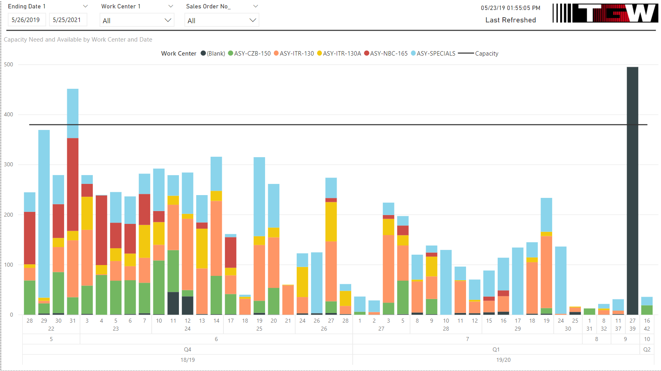

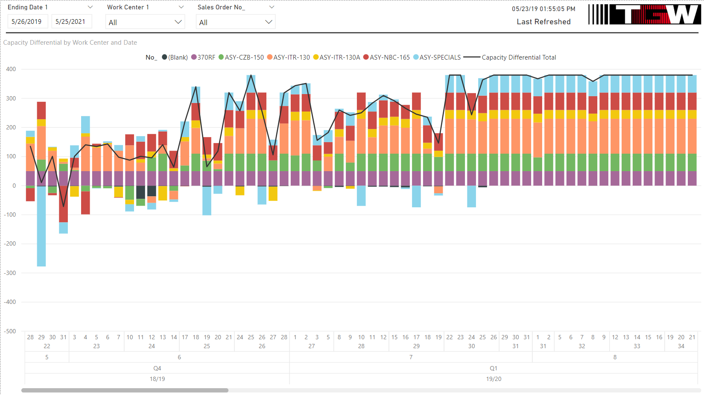

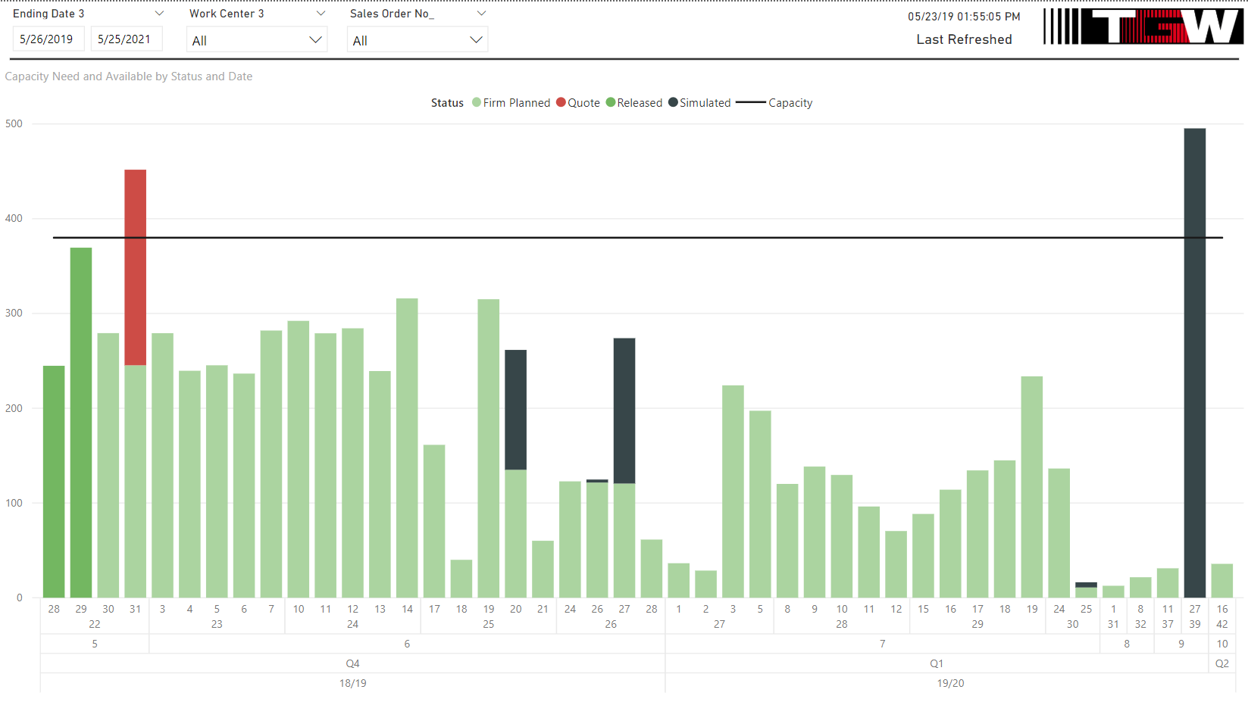

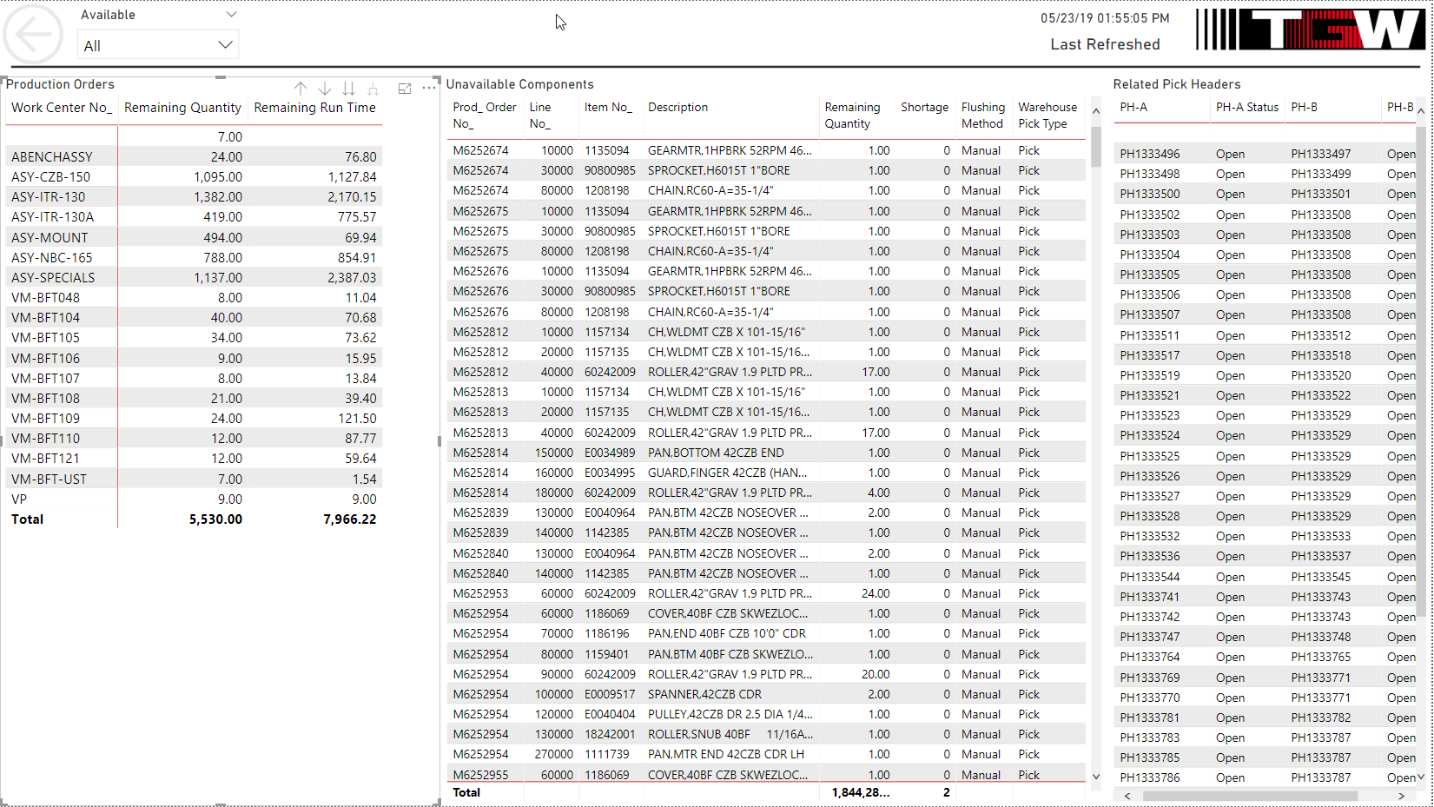

Additionally, we have used the data warehouse to create standardized tables like the following date table and the subsequent production order line view that is used for several reports used in daily production (morning meetings, shift change, level loading, etc.).

### Date Table Example

--Datebase

USE US_DataWarehouse;

--Variable declaration

DECLARE @Start_date DATE = '01/01/2001', @End_date DATE = '12/31/2050';

SET DATEFIRST 1;

SET DATEFORMAT mdy;

--Create temporary table to give values to permanent table

CREATE TABLE #temp

([Date] DATE PRIMARY KEY

,[Day] AS DATEPART(DAY, [date])

,[Month] AS DATEPART(MONTH, [date])

,[First of Month] AS CONVERT(DATE, DATEADD(MONTH, DATEDIFF(MONTH, 0, [date]), 0))

,[Month Name] AS DATENAME(MONTH, [date])

,[Week] AS DATEPART(WEEK, [date])

,[ISOweek] AS DATEPART(ISO_WEEK, [date])

,[Day of Week] AS DATEPART(WEEKDAY, [date])

,[Quarter] AS DATEPART(QUARTER, [date])

,[Year] AS DATEPART(YEAR, [date])

,[First of Year] AS CONVERT(DATE, DATEADD(YEAR, DATEDIFF(YEAR, 0, [date]), 0))

,[Style112] AS CONVERT(CHAR(8), [date], 112)

,[Style101] AS CONVERT(CHAR(10), [date], 101)

);

--Generate and insert values into temporary table

INSERT #temp([Date])

SELECT vals

FROM (SELECT vals = DATEADD(DAY,row_num - 1, @Start_date)

FROM (SELECT TOP (DATEDIFF(DAY, @Start_date, @End_date))

row_num = ROW_NUMBER() OVER (ORDER BY sao.[object_id])

FROM sys.all_objects AS sao

CROSS JOIN sys.all_objects AS sao2

ORDER BY sao.[object_id]

) AS x

) AS y;

--Create permanent table

/*

CREATE TABLE [dbo].[TGW-ERMANCO$Date]

(

[Date] DATE NOT NULL PRIMARY KEY

,[Day] TINYINT NOT NULL

,[Month] TINYINT NOT NULL

,[Year] INT NOT NULL

,[Week] TINYINT NOT NULL

,[Calendar Quarter] TINYINT NOT NULL

,[Day of Week Number] INT NOT NULL

,[Day of Week Name] VARCHAR(3) NOT NULL

,[Week in Month] INT NOT NULL

,[Month Name] VARCHAR(10) NOT NULL

,[Fiscal Year] VARCHAR(5) NOT NULL

,[Fiscal Quarter Number] TINYINT NOT NULL

,[Fiscal Quarter Name] VARCHAR(2) NOT NULL

,[Weekend] BIT NOT NULL

,[First of Month] DATE NOT NULL

,[Last of Month] DATE NOT NULL

);

*/

--Load temporary values into table along with calculated values

INSERT INTO [dbo].[TGW-ERMANCO$Date]

SELECT [Date] = [Date]

,[Day] = [Day]

,[Month] = [Month]

,[Year] = [Year]

,[Week] = [Week]

,[Calendar Quarter] = [Quarter]

,[Day of Week Number] = [Day of Week]

,[Day of Week Name] = CONVERT(VARCHAR(3), DATENAME(WEEKDAY, [Day of Week] - 1))

,[Week in Month] = CONVERT(TINYINT, DENSE_RANK() OVER

(PARTITION BY [year], [month] ORDER BY [week]))

,[Month Name] = CONVERT(VARCHAR(10), [Month Name])

,[Fiscal Year] = CONVERT(VARCHAR(5), CASE

WHEN [Month] >= 7 THEN RIGHT(YEAR([Date]),2) + '/' + RIGHT((YEAR([Date]) + 1),2)

WHEN [Month] < 7 THEN RIGHT((YEAR([Date]) - 1),2) + '/' + RIGHT(YEAR([Date]),2)

END)

,[Fiscal Quarter Number] = CONVERT(TINYINT, CASE

WHEN [Quarter] = 1 THEN 3

WHEN [Quarter] = 2 THEN 4

WHEN [Quarter] = 3 THEN 1

WHEN [Quarter] = 4 THEN 2

END)

,[Fiscal Quarter Name] = CONVERT(VARCHAR(2), CASE

WHEN [Quarter] = 1 THEN 'Q3'

WHEN [Quarter] = 2 THEN 'Q4'

WHEN [Quarter] = 3 THEN 'Q1'

WHEN [Quarter] = 4 THEN 'Q2'

END)

,[Weekend] = (CASE

WHEN [Day of Week] >= 6 THEN 1

ELSE 0

END)

,[First of Month] = [First of Month]

,[Last of Month] = DATEADD(DAY, -(DAY(DATEADD(MONTH, 1, [Date]))), DATEADD(MONTH, 1, [Date]))

FROM #temp

### Production Order Modified Example

SELECT pl.[Prod_ Order No_]

,pl.[Sales Order No_]

,pl.[Segment]

,(pl.[Sales Order No_]+'-'+pl.[Segment]) AS 'Sales Order Key'

,i.[No_]

,i.[Description]

,i.[Global Dimension 2 Code]

,d.[Name]

,(i.[Global Dimension 2 Code] + ' - ' + d.[Name]) AS 'Item Class - Name'

,pl.[Item Category Code]

,pl.[Due Date] AS 'Assembly due date'

,pl.[Ending Date] AS 'Stockroom Due Date'

,pl.[Pick Operation Header No_] AS 'A Type Header'

,pl.[Pick Operation Hdr_ No_ B-Side] AS 'B Type Header'

,ISNULL((SELECT SUM(poc.[Shortage])

FROM [TGW-ERMANCO$Prod_ Order Component] AS poc

WHERE poc.[Prod_ Order No_] = pl.[Prod_ Order No_]

AND poc.[Status] IN (3,4)

AND poc.[Due Date] BETWEEN (GETDATE() - 30) AND (GETDATE() + 30)

),0) AS 'Sum of Shortage(s)'

,ISNULL((STUFF(

(SELECT ',' + poc.[Item No_]

FROM [TGW-ERMANCO$Prod_ Order Component] AS poc

WHERE poc.[Prod_ Order No_] = pl.[Prod_ Order No_]

AND poc.[Status] IN (3,4)

AND poc.[Due Date] BETWEEN (GETDATE() - 30) AND (GETDATE() + 30)

AND poc.[Shortage] = 1

FOR XML PATH ('')

)

, 1, 1, ''

)

)

,'') AS 'Shortage(s)'

,ISNULL((STUFF(

(SELECT ',' + ncrd.[No_]

FROM [TGW-ERMANCO$NCR_Deviation] AS ncrd

WHERE ncrd.[Prod_ Order No_] = pl.[Prod_ Order No_]

FOR XML PATH ('')

)

, 1, 1, ''

)

)

,'') AS 'Related NCRD(s)'

,pl.[Remaining Quantity]

,pr.[Run Time]

,pl.[Remaining Quantity] * pr.[Run Time] AS 'Remaining Run Time'

,(SELECT pr2.[Work Center No_]

FROM [TGW-ERMANCO$Prod_ Order Routing Line] AS pr2

WHERE pl.[Prod_ Order No_] = pr2.[Prod_ Order No_]

AND pr2.[Work Center Group Code] = 'ASSY'

) AS 'Work Center'

FROM [TGW-ERMANCO$Prod_ Order Line] AS pl

LEFT JOIN [TGW-ERMANCO$Prod_ Order Routing Line] AS pr ON pl.[Prod_ Order No_] = pr.[Prod_ Order No_]

LEFT JOIN [TGW-ERMANCO$Item] AS i on pl.[Item No_] = i.[No_]

LEFT JOIN [TGW-ERMANCO$Dimension Value] AS d ON i.[Global Dimension 2 Code] = d.[Code]

WHERE pl.[Remaining Quantity] > 0

AND pr.[Work Center Group Code] = 'ASSY'

AND pl.[Due Date] BETWEEN (GETDATE() - 35) AND (GETDATE() + 35)

AND pl.[Item Category Code] = 'PRODUCT'